Setup Docker Desktop

Download the installer
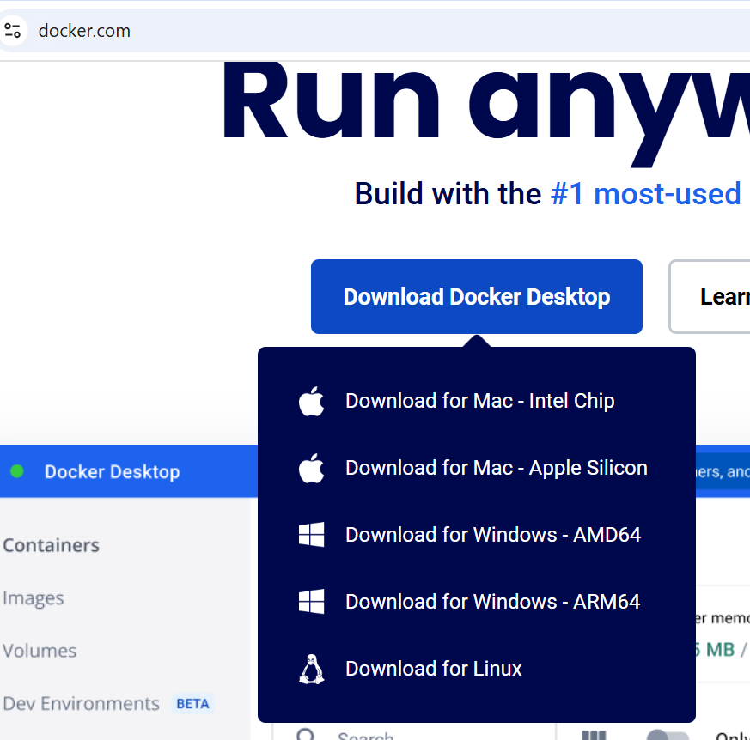
Run it
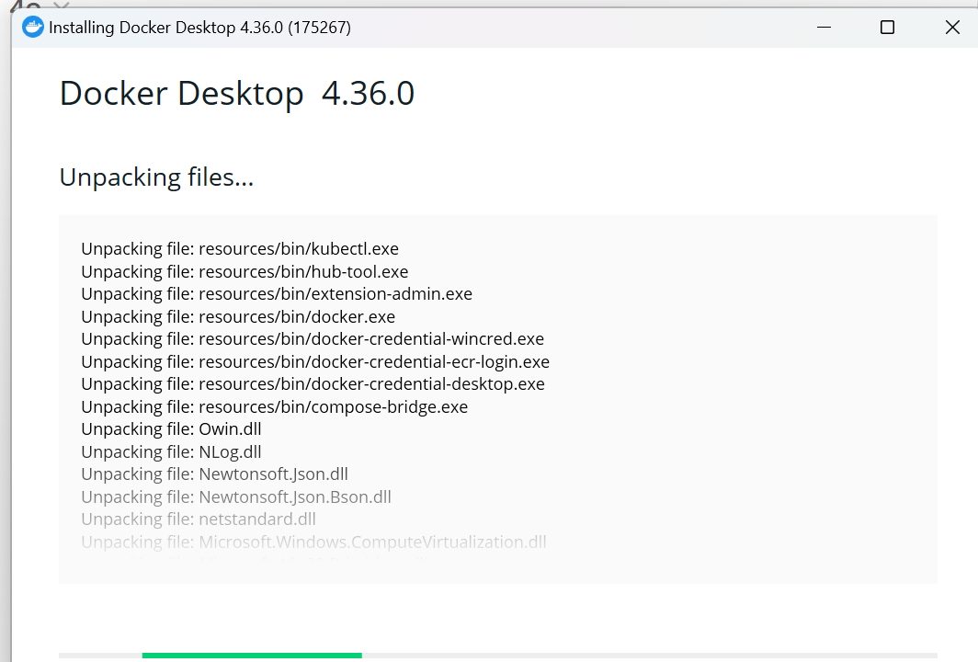
Once it completes it will ask to restart. Can save your files and click on the “Close and restart” prompt
Run the Docker desktop shortcut
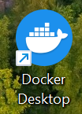
Choose default and click on Finish
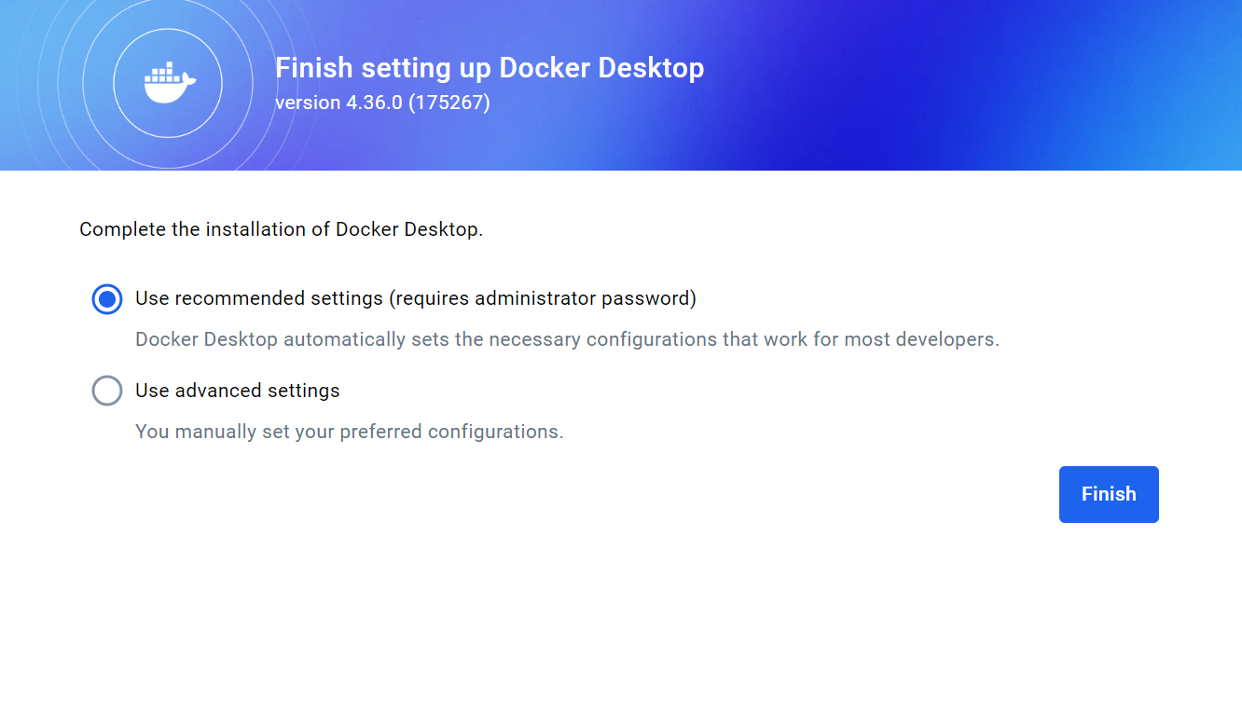
They will prompt for admin and just key in your admin credentials (if any) and click on yes then it will reach this page which you can skip
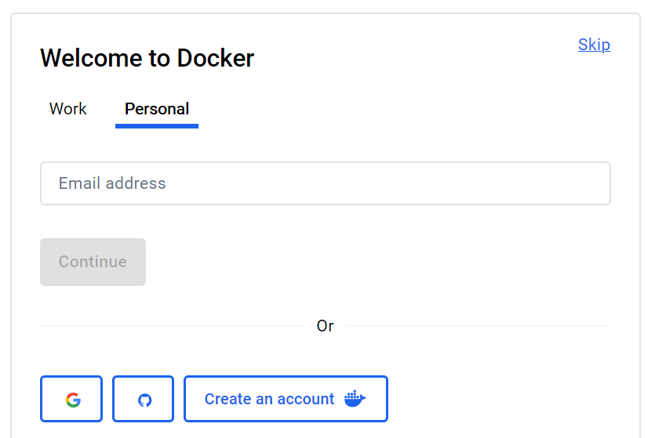
Can skip this as well
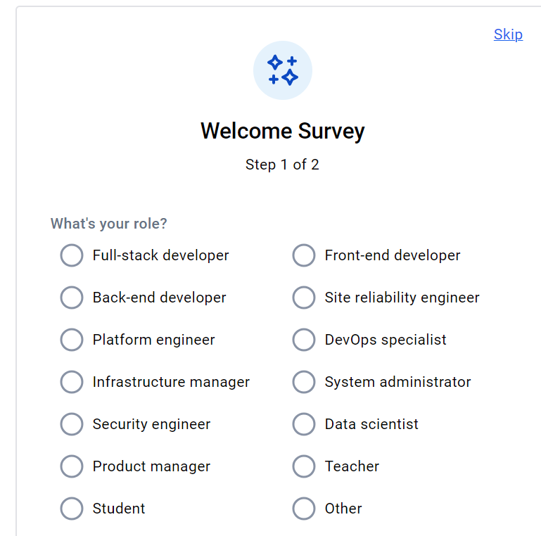

Now you are in!
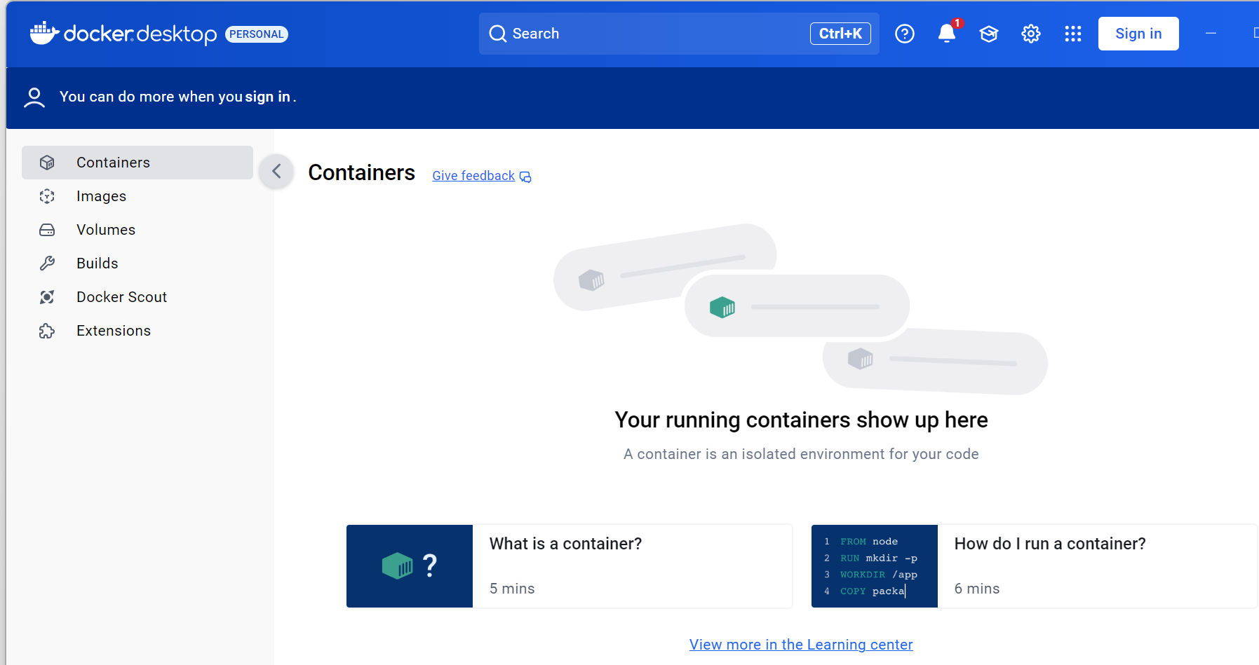
You can also verify it in CLI
